Create And Configure IBM Cloud Service Create A Database in Cloudant DB

|  |  |
| --- | --- |
| **Date** | **29 October 2022** |
| **Team ID** | PNT2022TMID40587 |
| **Project Name** | Iot Based Signs with Smart Connectivity for Better Road Safety |
| **Maximum Marks** | **4 Marks** |

# AIM

To create a database in Cloudant DB to store location data

# STEPS

1. Login to IBM Cloud with smart internz mail ID and Password.

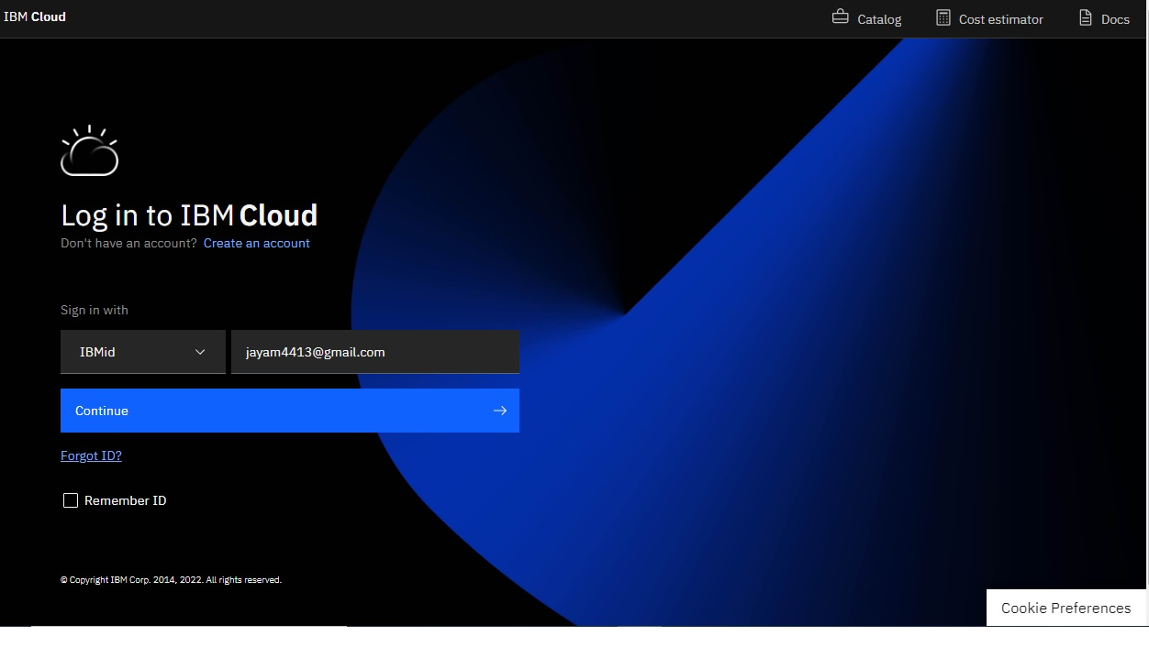

1. 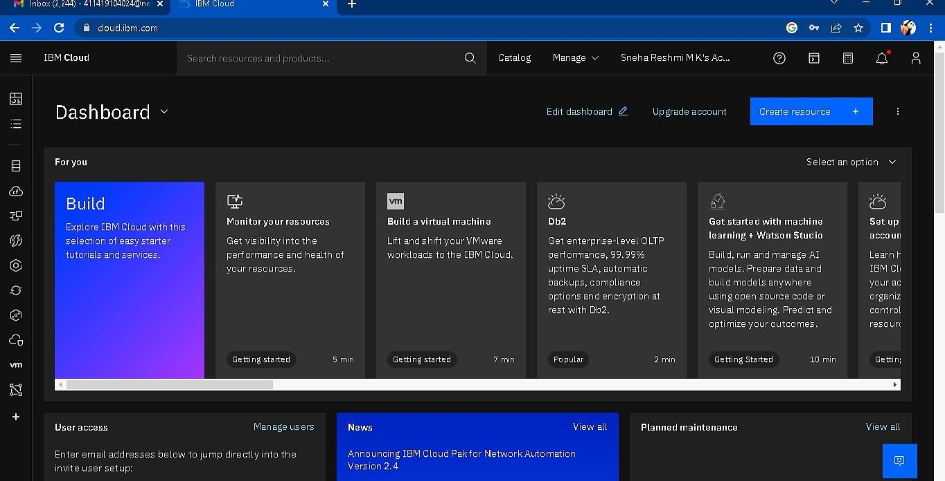Click “Create Resource +” button
2. 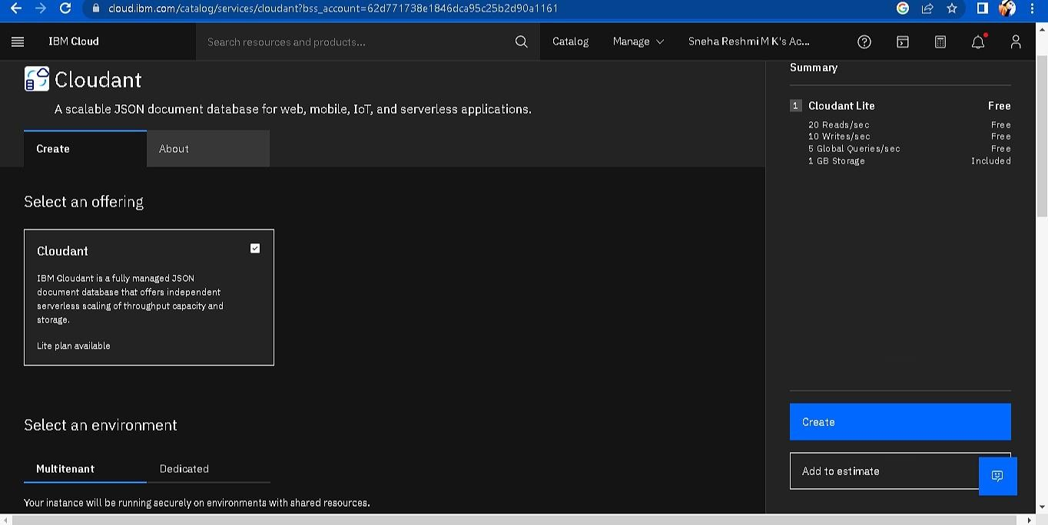Search Cloudant in Catalog then Choose the Lite version

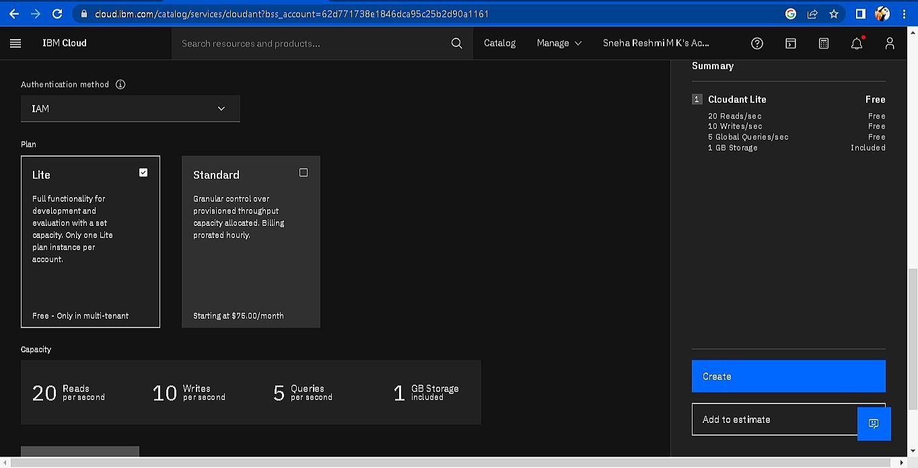

1. 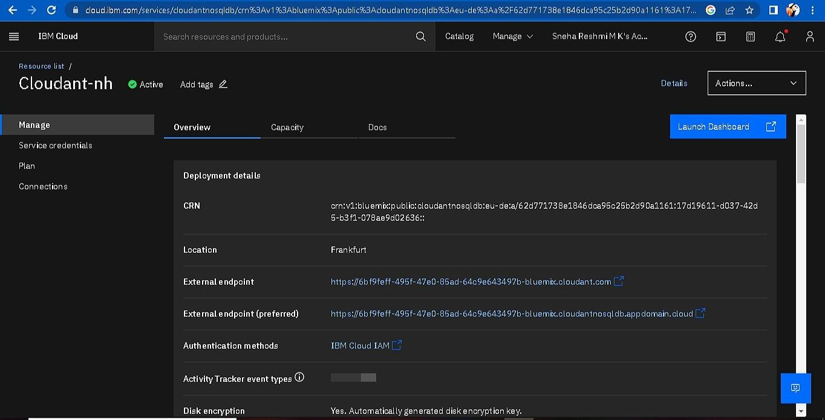The Cloudant database resource created
2. click on launch dashboard

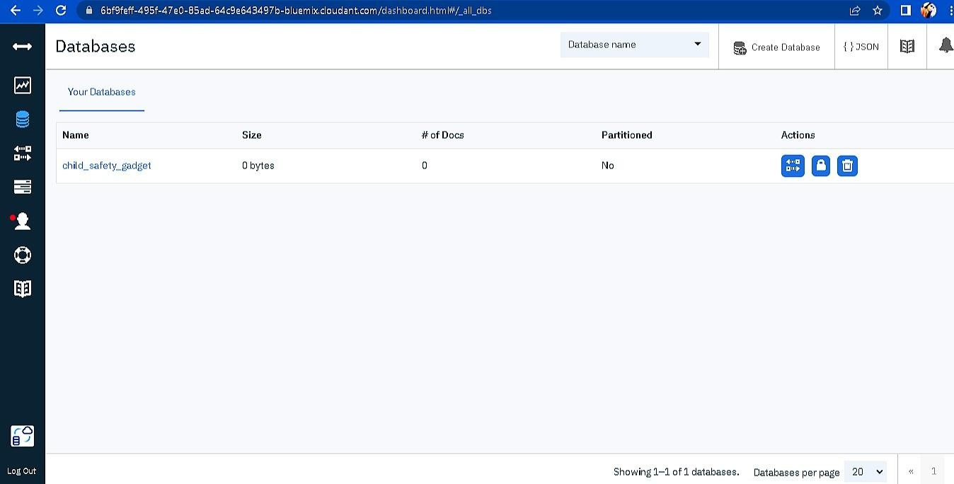

1. Click “Create Database”. Entered “child_safety_device” as the database name and the “Non-partitioned” option.
2. The database “child_safety_device” has been created and it's work Successfully

# RESULT:

A database to store the location data on Cloudant DataBase has been created successfully.

TEAM ID : PNT2022TMID40587 TEAM LEADER : PARTHIBAN N TEAM MEMBER 1 : ANANDHALAKSHMI S

TEAM MEMBER 2 : JEGANATHAN T

TEAM MEMBER 3 :TAMILARASAN TEAM SIZE : 4

MENTOR : Arularumugam